Swachh Bharat Clean City Connect Website – Project Report
Name of Innovator: Ayisha Mohammed
Start Date: 25/11/2025
End Date: 01/12/2025
Project Title: Clean India Connect – Swachh Bharat Digital Awareness Platform Using v0.dev

Day 1 – Empathise & Define

Step 1: Understanding the Need

Which problem am I trying to solve?
Even today, garbage dumping, waste overflow, clogged drains and unhygienic surroundings are common in many public spaces. People want cleaner streets but don’t know how to report issues, where to dispose waste properly, or how to contribute to the Swachh Bharat movement.
I realised that a digital awareness platform can drive behaviour change, spread environmental knowledge and motivate active participation.

Who is affected by this problem?
• Common citizens & families
• Students & youth groups
• Municipal staff & sanitation workers
• Children who grow learning from society

How did I identify this problem?
✔ Observation during daily life
✔ Cleanliness activities in college/community
✔ Public feedback & group discussions
✔ Environmental awareness study

Step 2: What is the Problem?

Problem Statement
I am building a Swachh Bharat Awareness Website that educates the public, promotes cleanliness habits, provides waste management tips, encourages volunteering and creates a space for responsibility-driven action.

Why solving this matters:
• Clean surroundings reduce diseases
• Awareness builds long-term behavioural change
• Digital access increases participation
• Young minds learn responsibility early

Take-Home Findings from People:
• People know but don’t practice cleanliness
• Posters and visuals influence better than text
• Youths showed strong interest in volunteering
• Awareness must be continuous, not one-day

Day 2 – Ideate

Step 3: Brainstorming Solutions
- Cleanliness awareness website
- Waste segregation & disposal guide
- Swachh Bharat mission info & goals
- Posters, slogans & motivational visuals
- Clean city strategies explained simply
- Volunteer/awareness event registration (future feature)

Step 4: My Favourite Solution
A simple but powerful awareness-based Swachh Bharat website accessible to everybody — students, citizens, schools and communities.

Step 5: Why I Chose This Approach
• Access anytime, anywhere digitally
• Visually engaging content inspires action
• Helps spread national cleanliness mission
• Encourages volunteering and community effort

Day 3 – Prototype & Test

Step 6: Prototype – First Version
My Swachh Bharat website includes:
• Swachh Bharat mission information
• Clean India awareness messages
• Clean City Strategies to maintain hygiene
• Recycling & waste segregation knowledge
• Posters, slogans & motivational quotes
• Educational UI designed in v0.dev
AI Tools Used: v0.dev, ChatGPT

Step 7: Testing & Feedback
What worked well:
✔ UI felt clean, organised and easy to explore
✔ Posters helped create strong visual awareness
✔ Content was simple and beginner-friendly
Areas to Improve:
• Add volunteer registration page
• Include quiz/knowledge test section
• add videos and infographics

Day 4 – Showcase

Step 8: Presenting My Innovation

Final Project Title:
Clean India Connect – Swachh Bharat Awareness Website

Impact:
• Motivates responsible waste habits
• Spreads environmental awareness online
• Encourages youth to join cleanliness drives
• Makes awareness accessible & continuous
Website Link (Paste here):
🌐 https://v0.app/chat/swachh-bharat-website-sBOaLRpfRC8?ref=8M69DV

Day 5 – Reflection

What I enjoyed most:
Creating posters and awareness content that can genuinely influence society and encourage people to maintain cleanliness.

My biggest challenge:
Choosing the simplest form to present impactful awareness content.

Take-Home Task:
Add volunteer Enrollment, quiz section, and community connections.
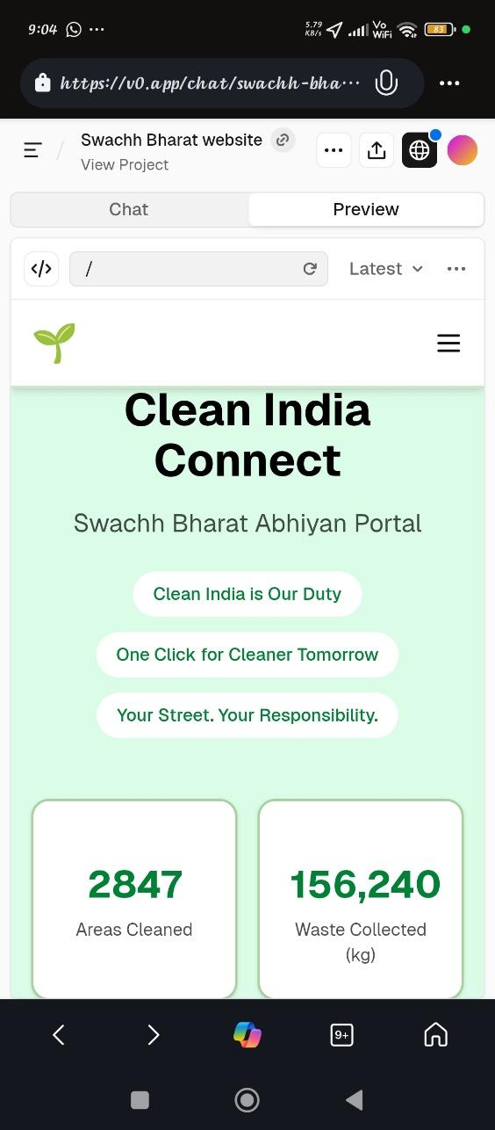
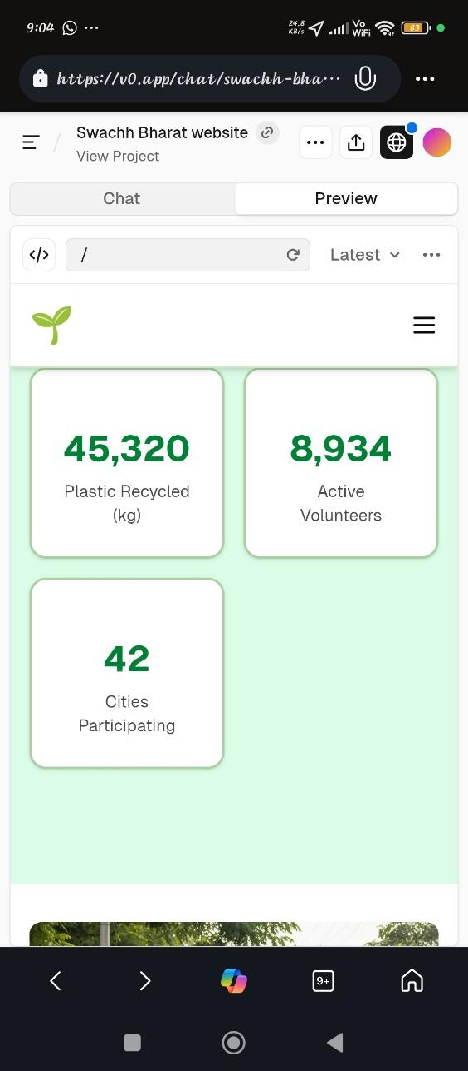
AI Tools Used: v0.dev, ChatGPT

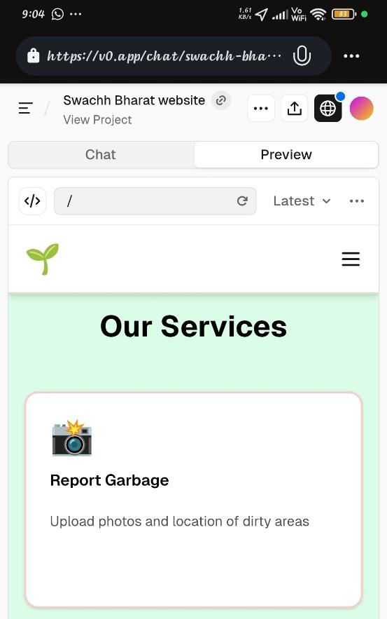
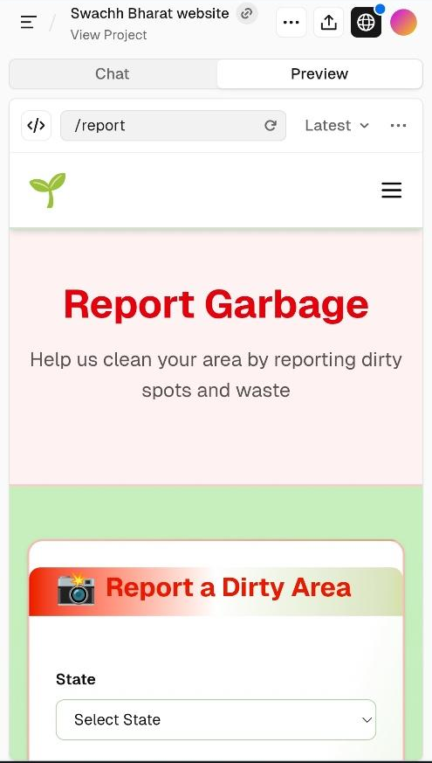
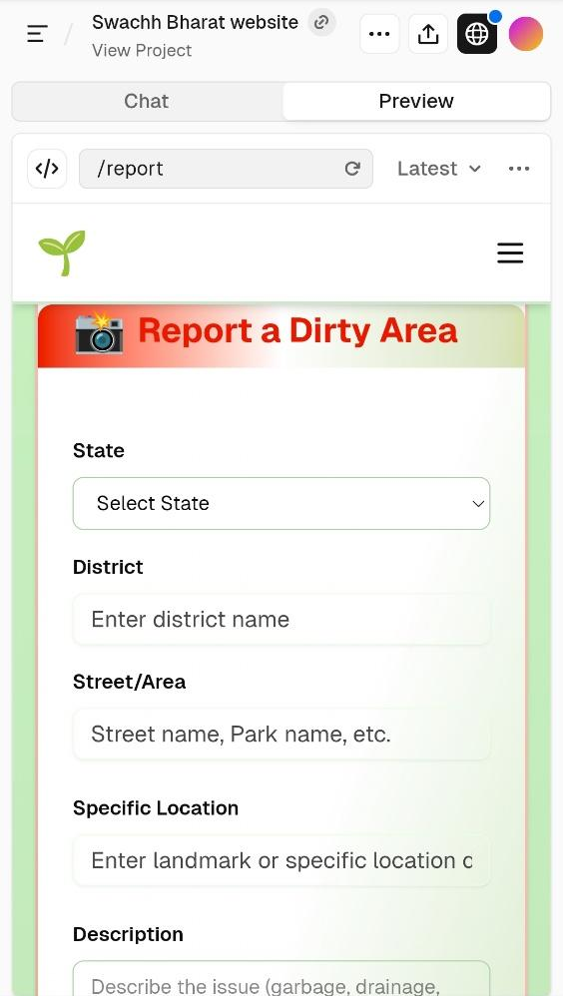
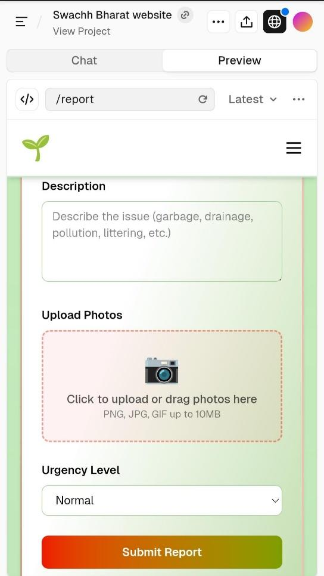
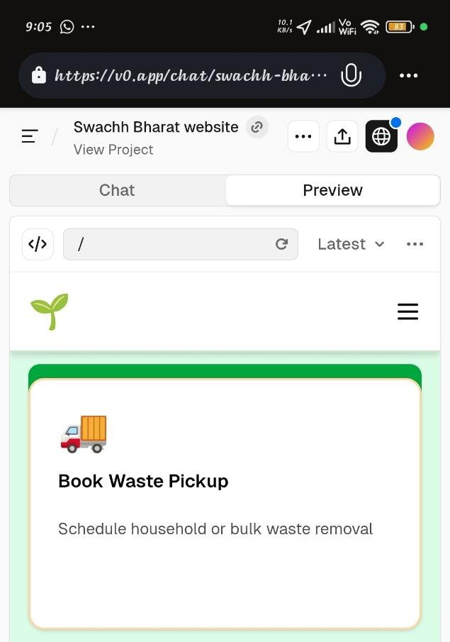
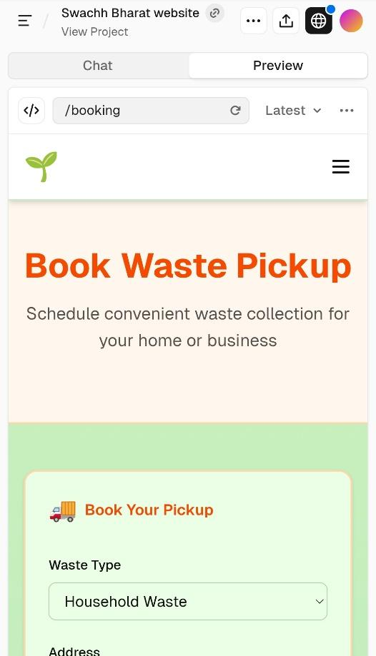
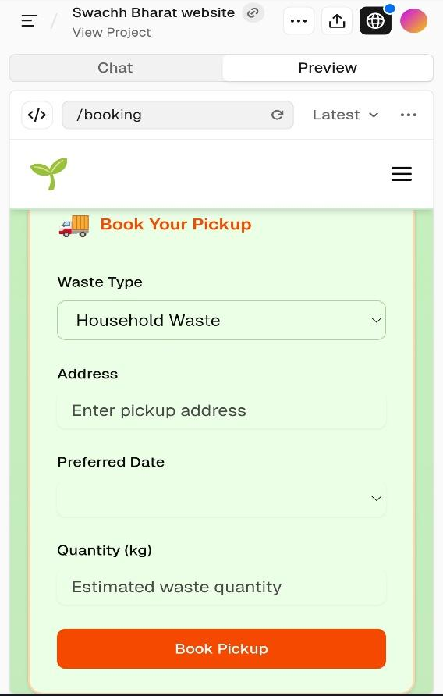
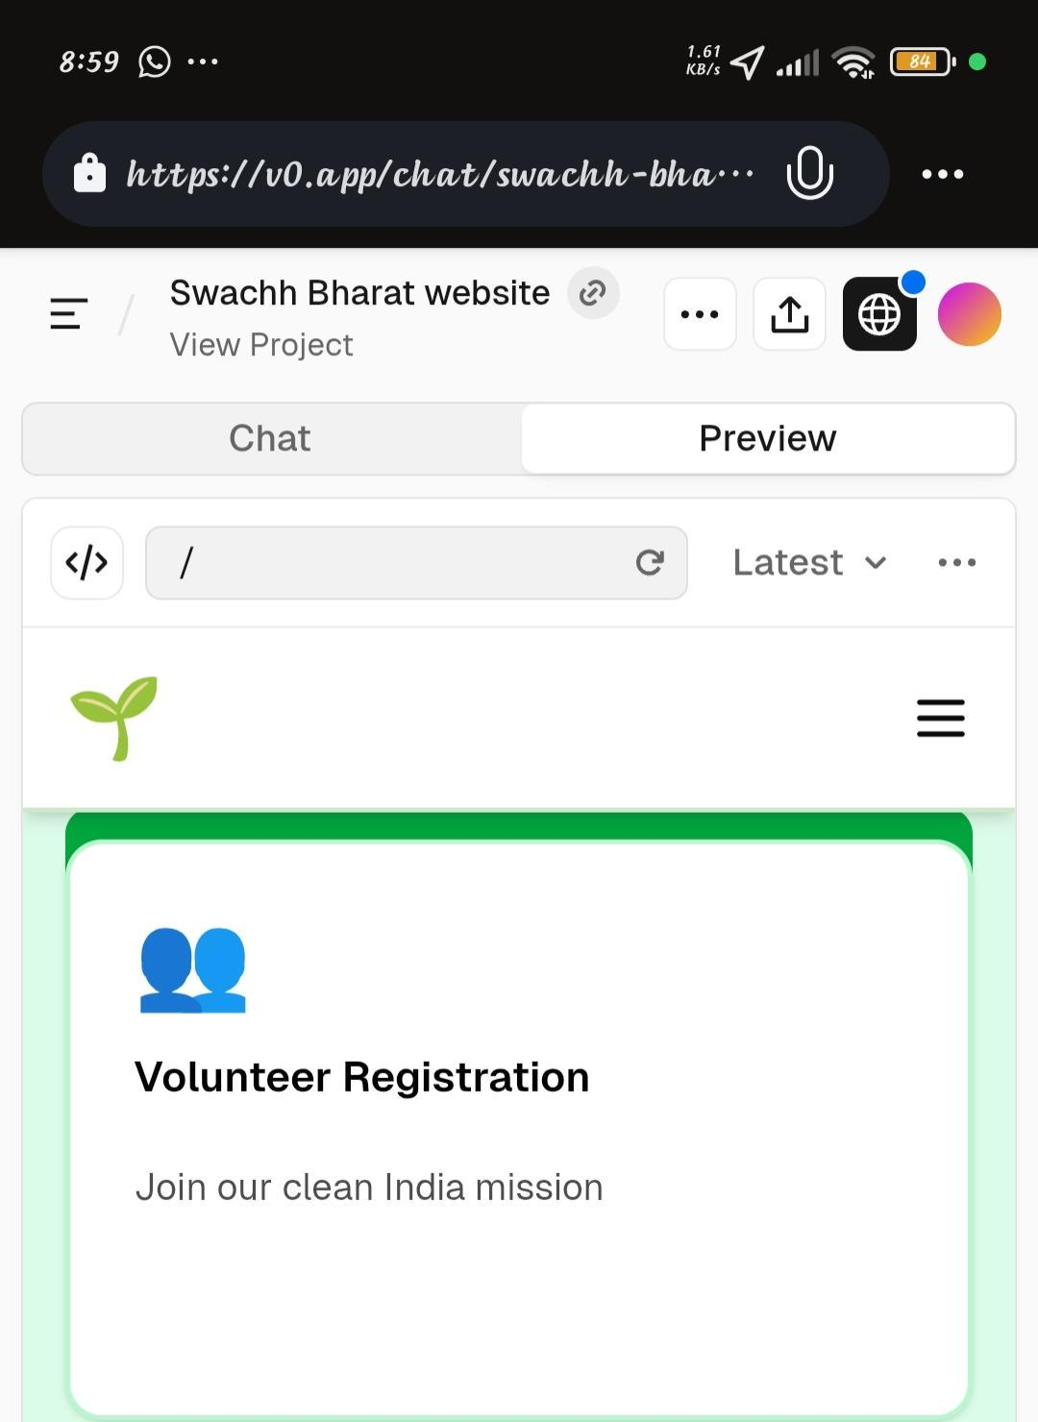
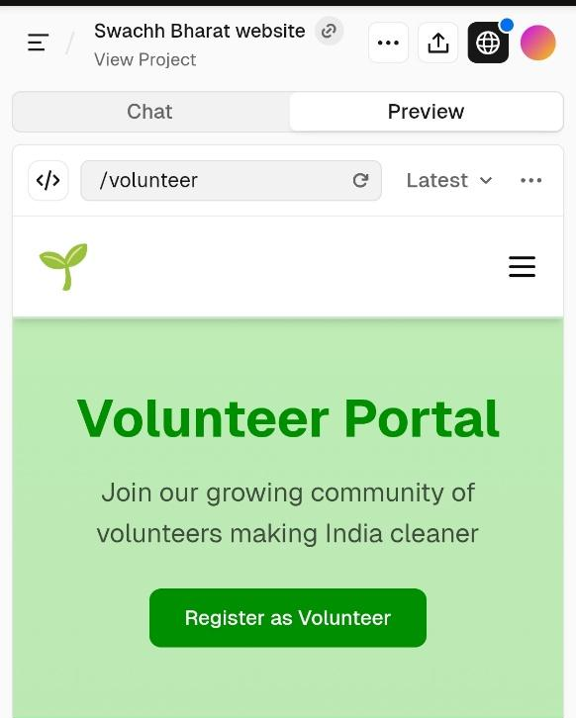
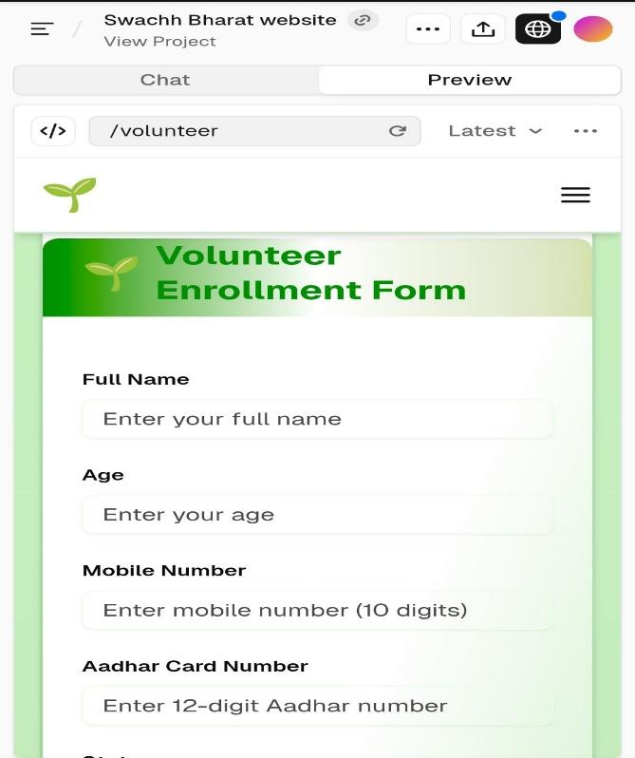
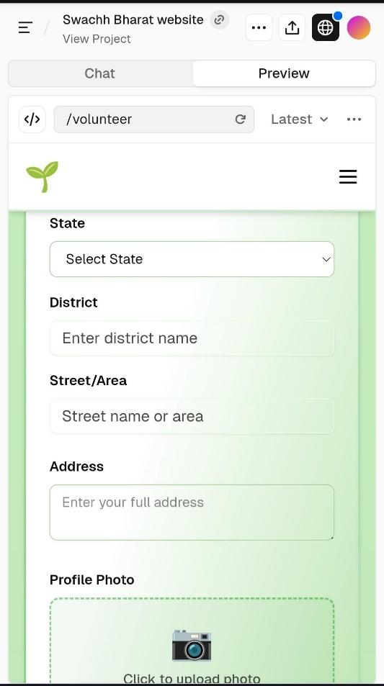
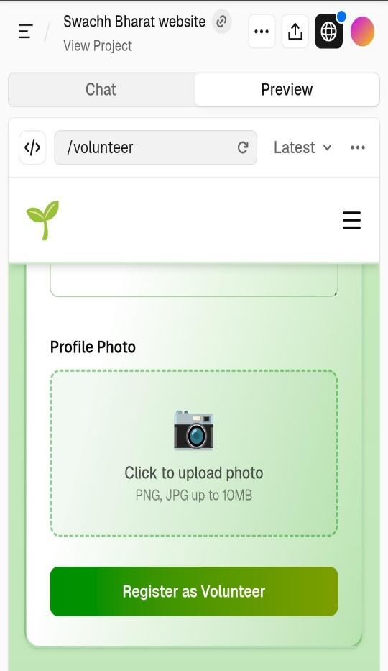

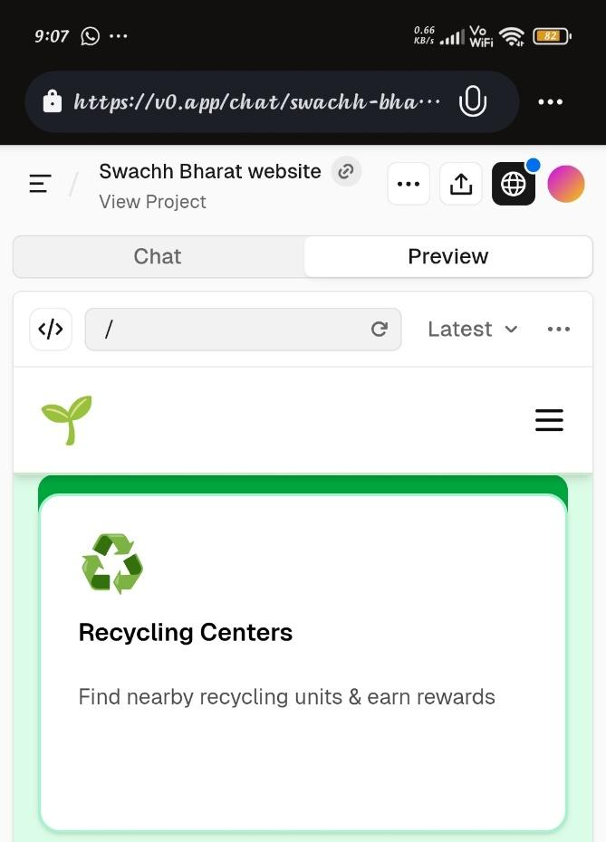
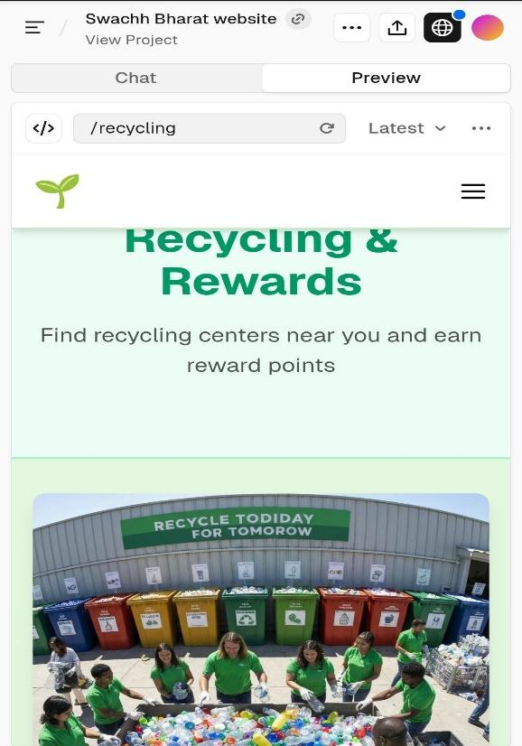
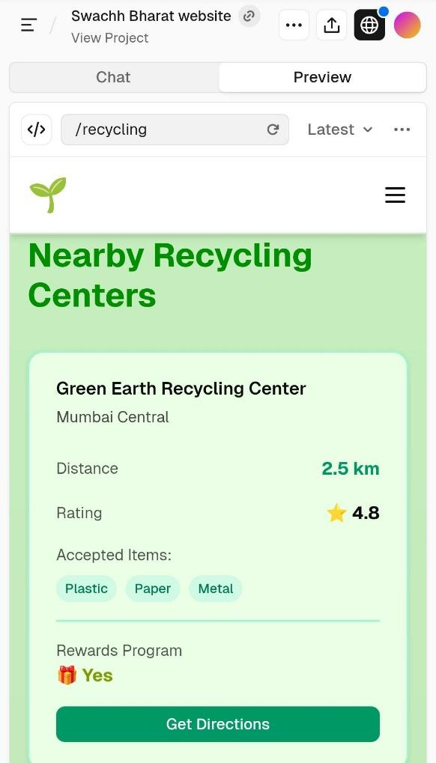
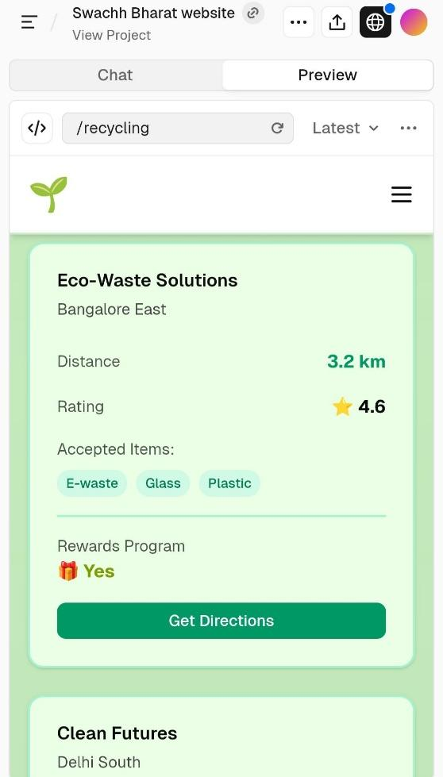
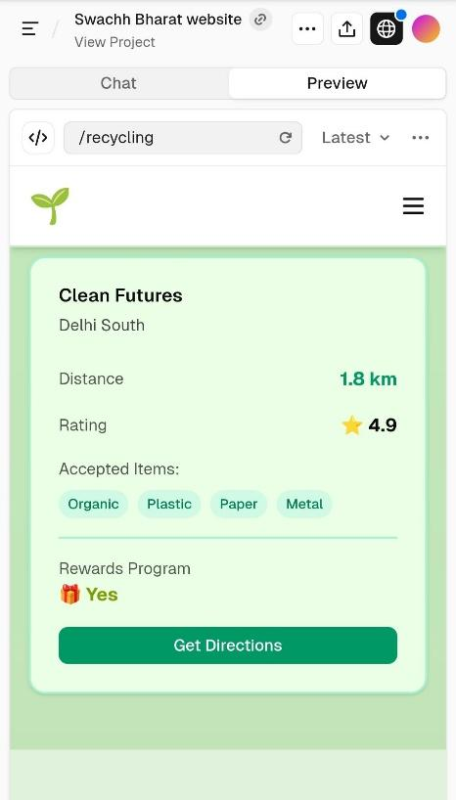
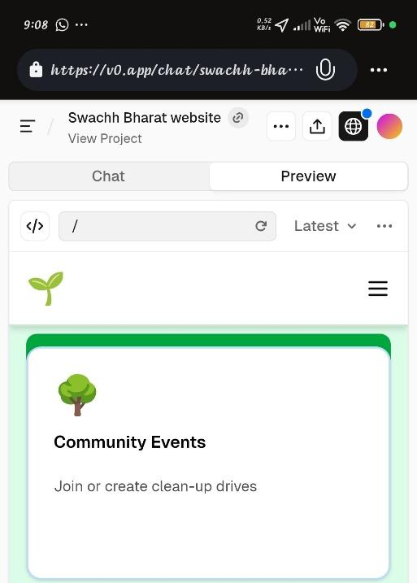
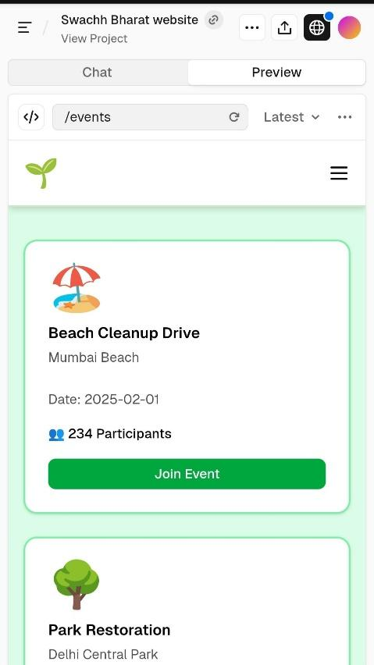
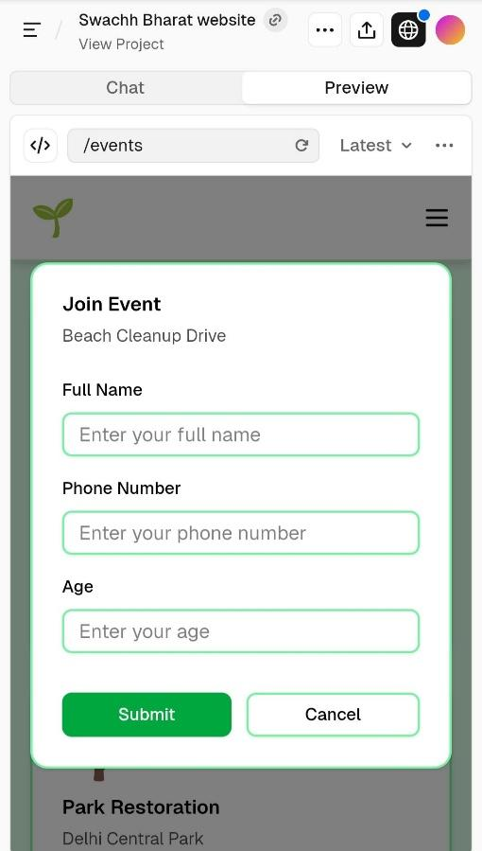

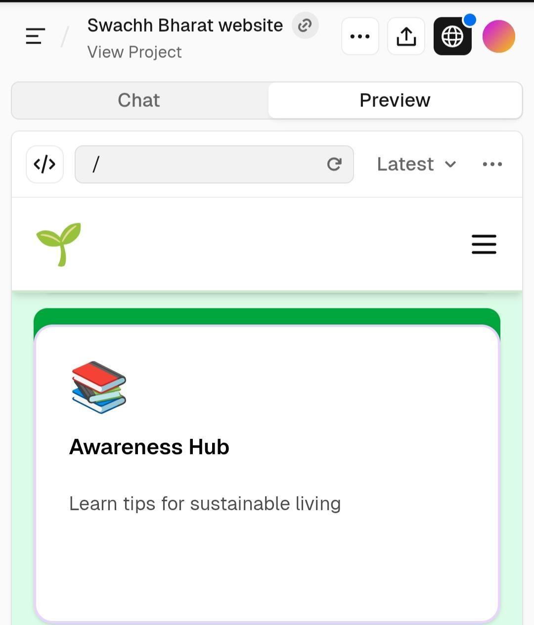
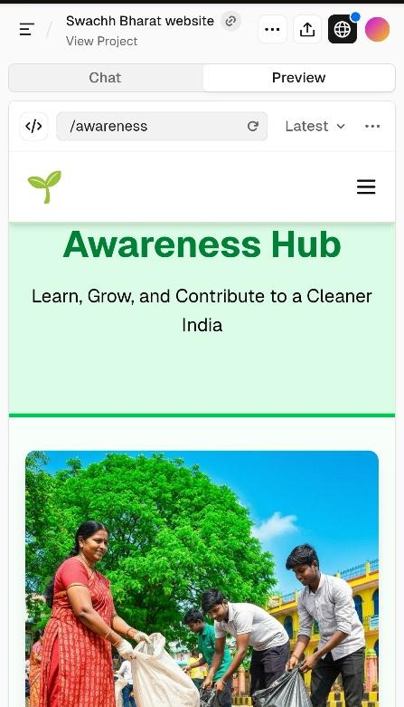
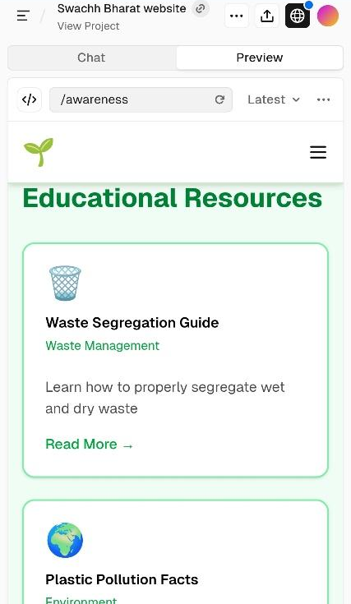
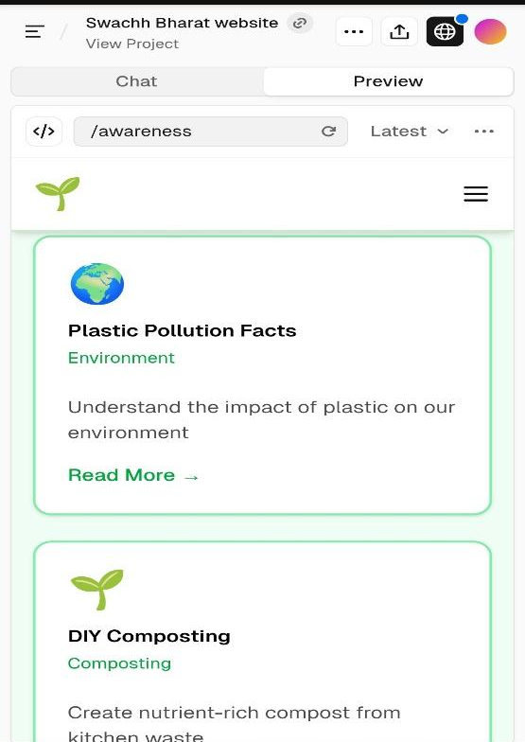
Outcomes & Learnings
By the end of this project, I was able to:
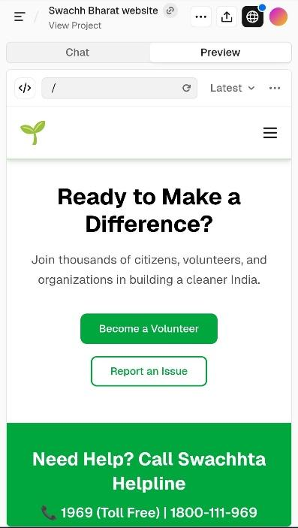
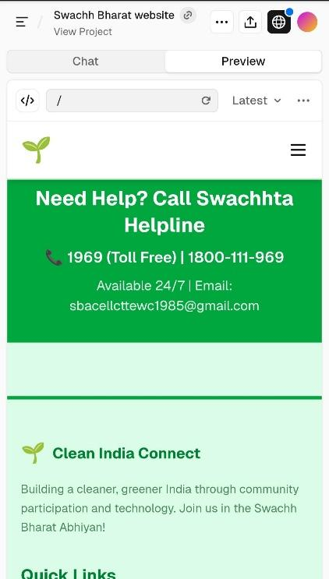
- Understand real challenges in public cleanliness
- Build an awareness-based Swachh Bharat website
- Improve my UI, structuring and content design skills
- Learn how digital tools can bring social impact
- Convert a civic issue into a digital platform solution
- Experience complete design thinking steps
- Realise that “Clean India begins with one person.

